These are all the bugs I was able to find in the Homage app, as a part of Part 3 of the assignment. The screenshot below is from Notion, and the Notion Document Link in attached below.

I used Notion as it was clean and I had a relatively greater familiarity with it, with respect to JIRA, however I am fully proficient in JIRA too, and can use it if need be.

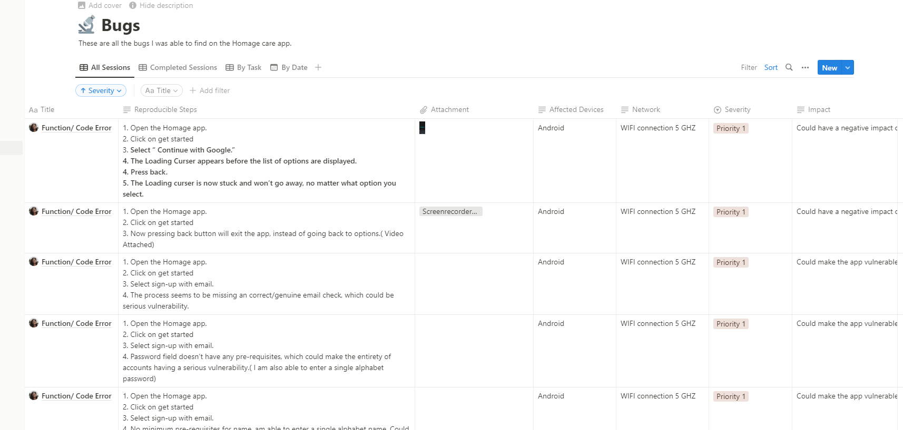

[Notion LINK](https://glossy-target-5b4.notion.site/8824c1e845034bba8b0e870c86904e65?v=7f1c77977f0e43d7807c77fe66cc4553)